SPRING TERM SCHOLASTIC BOOK FAIR:
MONDAY 20TH MARCH – THURSDAY 23rd MARCH 2023
Dear Parents/Carers,
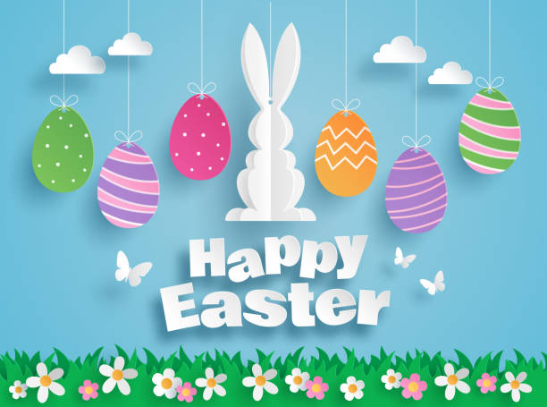
It is almost that time again, when the Scholastic Book Fair visits us here at Normanton Junior Academy! Last term we raised the largest amount in NJA Book Fair history - £861.09. We were blown away by the support for school books, and we are beyond grateful! We bought half class sets of our curriculum books. This means that the children can enjoy reading their class text even more. We also bought books for the four classes who won our reading trophies last term. Our mission to continue to build our curriculum based on books continues and this Spring Book Fair, we would like to raise enough to purchase half class sets of our summer term books. We would also like to fill our school library with even more copies of the children’s favourite texts. Copies of the latest Tom Gates books could be coming your way very soon!

The book fair will be in school, next week, between Monday 20th and Thursday 23rd March. The fair will run in the same way as it did last term in the main school hall.
Fill your minds as well as your tummies this Easter!

When can I visit?
- Your child will be given an opportunity to visit the book fair with their class during the school day. If you are unable to attend after school, please ensure that they have money in a labelled purse or envelope if you would like them to be able to purchase a book.
  - The days will be as follows: Y3 – Monday, Y4 -Tuesday, Y5 – Thursday and Y6 – Thursday.
If your child forgets their money, please don’t worry. If they let their teacher know and they will arrange an appropriate time to go with an adult. This is especially relevant for Y5/6 who often walk home alone, so might want a second opportunity to visit the fair.
- The book fair will be open after school Monday – Thursday, 15:00 – 15:30, for you to attend with your child. Please come to the main school hall after collecting them. There will also be a secret ‘don’t tell the kids slot’, each day, from 2:45pm This is so that you can purchase Easter gifts and/or birthday treats without the children seeing! The books at the fair are such good value, with new lower than £5 ranges added!
How can I pay?
- You can pay in cash on the day.
- You can pay with a prepaid voucher. Please see the Scholastic website for more details. Please note you will need to print these and no change can be given if paying with a prepaid voucher. Vouchers are only valid for the period of the book fair.
- If you have access to the internet on you phone, then you can make an online payment at the book fair and pay by card. This can be accessed using a QR code that will be made available at the book fair.
We look forward to welcoming you to school for this brilliant event, and thank you again for your continued support.

J Houghton
Reading Lead, Normanton Junior Academy

